**Windows 10 UWP – Hands on Lab**

**Lab 1:**

**Note**: The demo app created for this lab uses Visual Studio 2015 with the latest Windows Tools SDK version 10240. To help with our coding efforts with the boiler code and page navigation we use a UWP app extension called Template 10.

1. Open VS2015 locate the Tools main option and select the option “Extension and Updates”. In the nuget search make sure to select Templates under the Online group. Search for the Template 10 extension by Jerry Nixon.

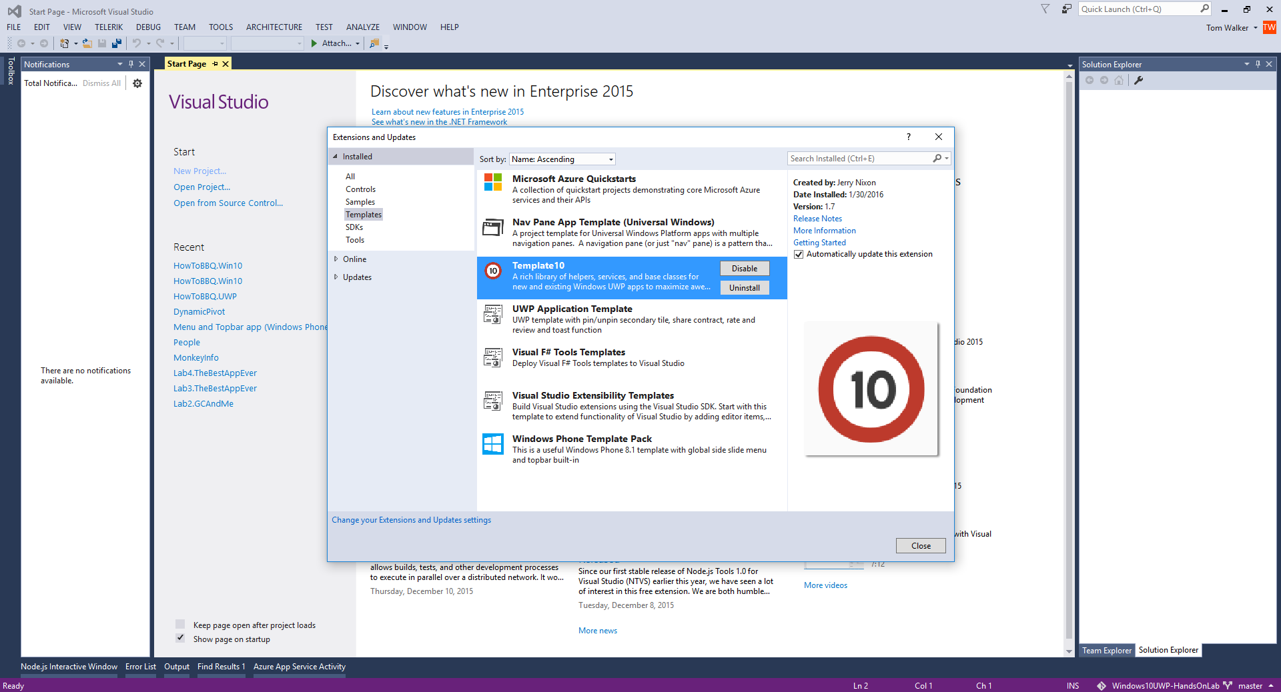

1. Once Template 10 has been installed. Create a new project using the Windows Universal Hamburger (Template 10) template. Name the project “HowToBBQ.Win10”. This will create our starting project Windows 10 UWP.

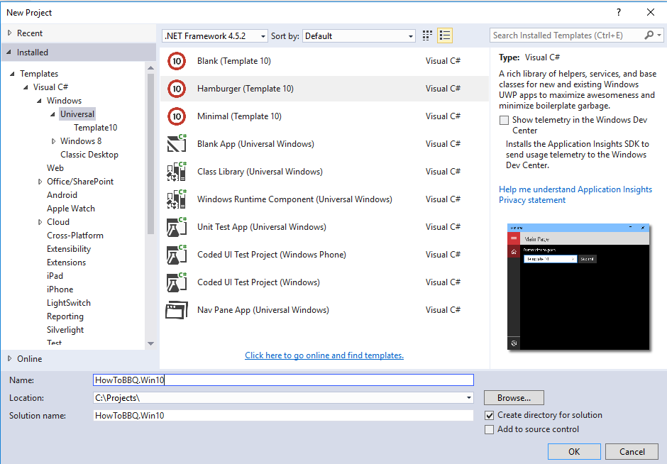

1. Hit F5 to run the app. This will test that your setup works.